Image logo:

https://byui-cse.github.io/wdd130-ww-course/resources/images/logos/logo6_200.png

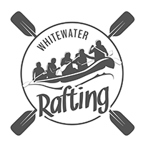

Write out the color codes for the following colors:

* + primary-color: D36135 Flame
  + secondary-color: 031D44 Oxford Blue
  + accent1-color: FCE762 Maize
  + accent2-color: FFFDED Ivory

the names of the fonts for the following labels:

* + heading-font: permanent marker
  + text-font: poppins

https://coolors.co/d36135-031d44-04395e-fce762-fffded